FOTOGRAMAS
MUESTRA DE CINE PALESTINO

OMAR
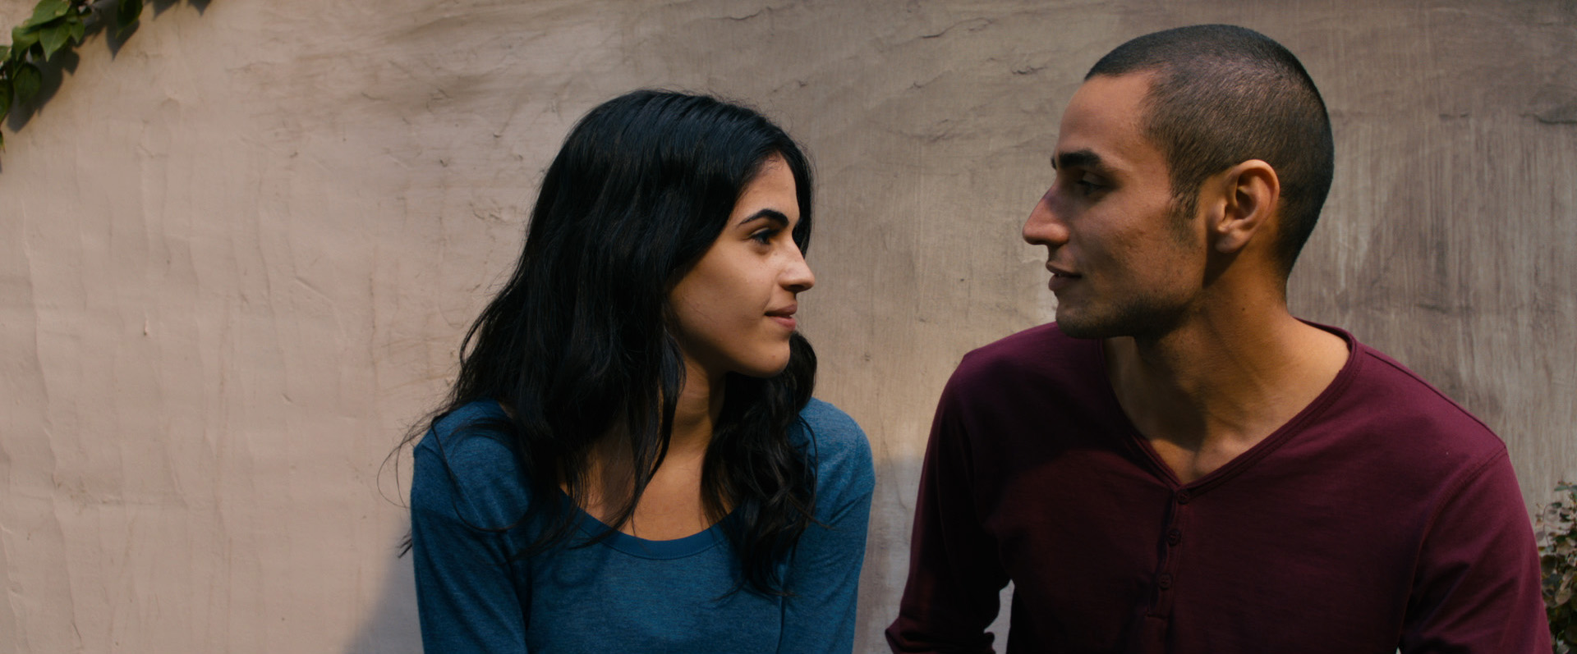

THE TIME THAT REMAINS

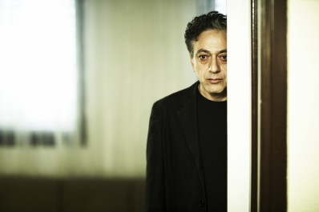

VILLA TOUMA
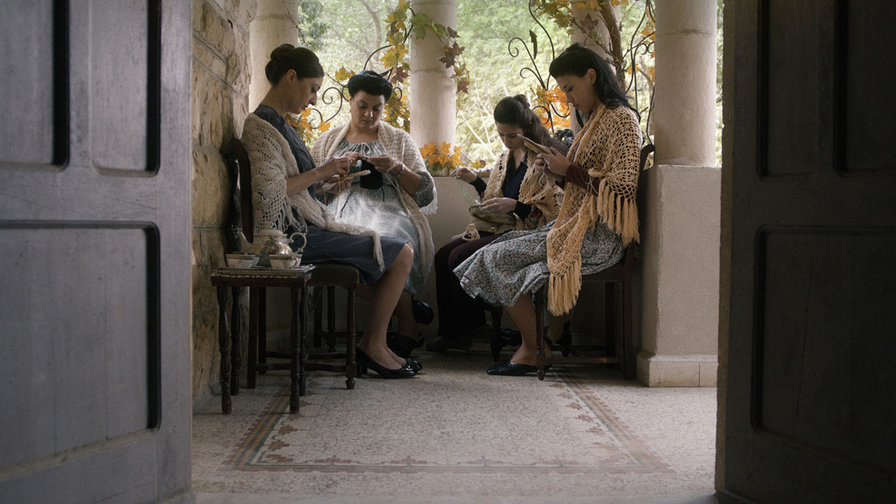

MY LOVE AWAITS FOR ME BY THE SEA
